Create the K8s EKS,further you have to do the deployment of the Nginx application and access the application outside the cluster.

Create the K8s EKS,

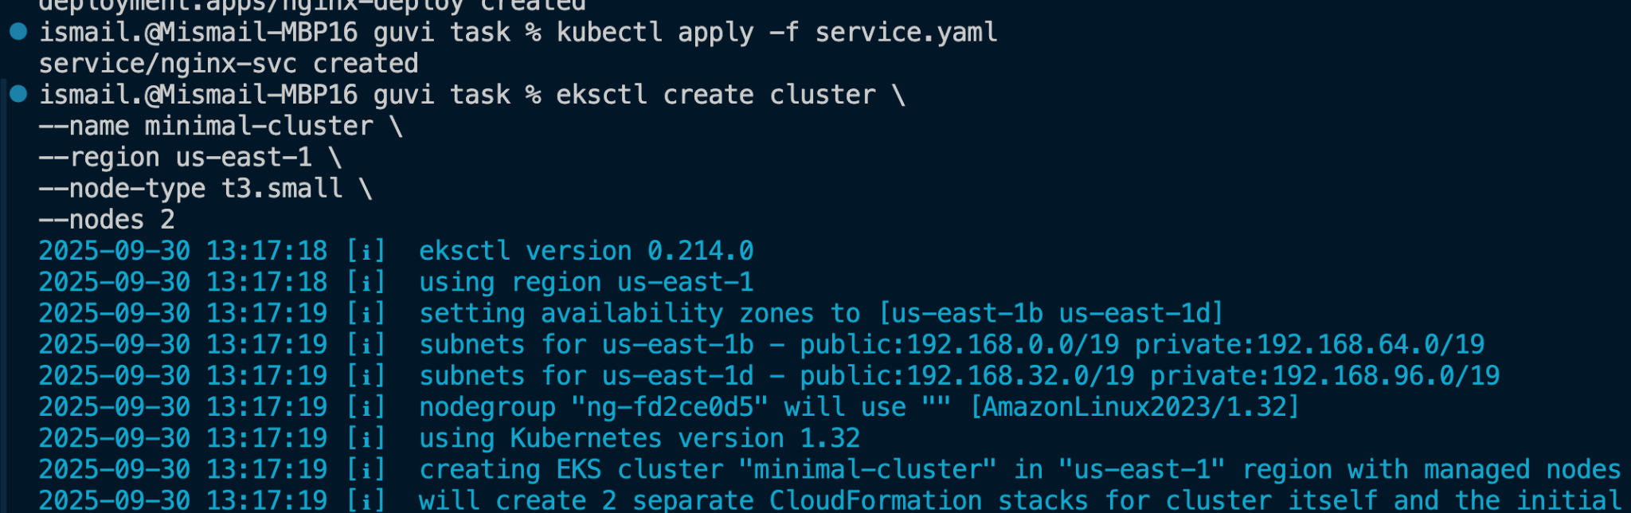

,further you have to do the deployment of the Nginx application

apiVersion: apps/v1

kind: Deployment

metadata:

name: nginx-deployment

spec:

replicas: 2

selector:

matchLabels:

app: nginx

template:

metadata:

labels:

app: nginx

spec:

containers:

- name: nginx

image: nginx:1.21

ports:

- containerPort: 80

---

apiVersion: v1

kind: Service

metadata:

name: nginx-service

spec:

type: LoadBalancer

selector:

app: nginx

ports:

- protocol: TCP

port: 80

targetPort: 80

access the application outside the cluster.

